

**Narula Institute of Technology**

**81, Nilgunj Road, Agarpara, Kolkata – 700109, West Bengal**

**Automatic attendence System using face recognition**

*A synopsis submitted for partial fulfilment for award of the degree of*

**Masters Of Computer Application**

**By**

RUDDRRANI MALLICK

SUJOY NANDI

SUBHAM CHAKRABERTTY

**Under the supervision of**

*Mrs. Debrupa Pal*

Professor at Narula Institute of Technology

Affiliated to Maulana Abul Kalam Azad University of Technology

**

**Certificate**

The report of the project titled – **“Automatic attendence using face recognition**”submitted by **Ruddrrani Mallick (**434122020015), **Subham Chakrabertty (**434122010025), **Sujoy Nandi (**434122010061) of MCA 4th semester of 2nd year, has been prepared under my supervision of the requirements for MCA degree in Maulana Abul Kalam Azad University of Technology. The report is hereby forwarded.

|  |  |
| --- | --- |
| **Name of the team members** | **University Roll Number** |
| RUDDRRANI MALLICK | 434122020015 |
| SUBHAM CHAKRABERTTY | 434122010025 |
| SUJOY NANDI | 434122010061 |

____________________ ____________________

Debrupa Pal Debrupa Pal

Project Guide Project Coordinator

________________________

RUPA SAHA

HOD OF MCA

Narula Institute of Technology, Kolkata –700109, India

**Acknowledgement**

We express our sincere gratitude to Debrupa Pal ma’am (Professor of Department of Computer Applications) as well as our Project Guide for extending her valuable time for us and guiding us for this project. We are also indebted to the other teachers for their unconditional help and inspiration.

|  |  |
| --- | --- |
| Name of the team members | Signatures |
| RUDDRRANI MALLICK |  |
| SUBHAM CHAKRABERTTY |  |
| SUJOY NANDI |  |

**Table Of Contents**

* Introduction
* Overview
* Scope of Project
* Implementation Technologies
* Software Development Life Cycle (SDLC)
* Feasibility Analysis
* System Requirements Specifications (SRS)
* E-R Diagram
* DFD
* User Interface & Design
* Coding
* Testing
* Cost Estimation Analysis
* Maintenance
* Bibliography
* Conclusion

**Introduction**

In colleges, universities, organizations, schools, and offices, taking attendance is one of the most important tasks that must be done daily. Most of the time, it is done manually, such as by calling by name or by roll number. The main goal of this project is to create a Face Recognition-based attendance system that will turn this manual process into an automated one. This project meets the requirements for bringing modernization to the way attendance is handled, as well as the criteria for time management. This software is installed in the classroom, where and student's information, such as name, roll number, class, sec, and photographs, is trained. The images are extracted using Open CV. Before the start of the corresponding class, the student can approach the system, which will begin taking pictures and comparing them to the qualified dataset. Logitech C270 web camera were used in this project as the camera. The image is processed as follows: first, faces are identified using OpenCV. An Excel sheet is developed, and it is updated every hour with the information from the respective class instructor.

**Overview**

Attendance is prime important for both the teacher and student of an educational organization. So, it is very important to keep record of the attendance. The problem arises when we think about the traditional process of taking attendance in the classroom. Calling name or roll number of the student for attendance is not only a problem of time consumption but also it needs energy. So, an automatic attendance system can solve all the above problems. There are some automatic attendances making system which are

currently used by much institution. One of such system is biometric technique and RFID System. Although it is automatic and a step ahead of traditional method it fails to meet the time constraint. The student must wait in queue for giving attendance, which is time taking. This project introduces an involuntary attendance marking system, devoid of any kind of interference with the normal teaching procedure. The system can be also implemented during exam sessions or in other teaching activities where attendance is highly essential. This system eliminates classical student identification such as calling name of the student, or checking respective identification cards of the student, which can not only interfere with the ongoing teaching process, but also can be stressful for students during examination sessions. In addition, the students must register in the database to be recognized. The enrolment can be done on the spot through the user

friendly interface.

**Scope of the Project**

The scope of this project is to develop face recognition attendance system.

Expected achievements to fulfil the objectives are:

● To detect the face segment from the video frame.

● To extract the useful features from the face detected.

● To classify the features to recognize the face detected.

● To record the attendance of the identified student.

We are setting up to design a system comprising of two modules. The first module (face detector) is a mobile component, which is basically a camera application that captures student faces and stores them in a file using computer vision face detection algorithms and face extraction techniques. The second module is a desktop application that does face recognition of the captured images (faces) in the file, marks the students register and then stores the results in a database for future analysis.

**Implementation Technologies**

* Python & its Libraries
* Open CV
* Database - MySQL
* Ms-Excel

**Software Development Life Cycle(SDLC)**

The project management life cycle has 4 phases. Each phase is described along with tasks need to complete it.

Four phases are-

1. Initiation
2. Planning
3. Execution
4. Closure

We have used Iterative and Incremental Development model (IID) for our project development. This development approach is also known as Iterative Waterfall Development approach.

Iterative and Incremental Development is a software development process developed in response to the more traditional waterfall model. This model is created to take care of such large projects. The large and complicated project chiefly demand better development and testing procedures. It is known for its repeated process. For that reason, we choose Waterfall Model.

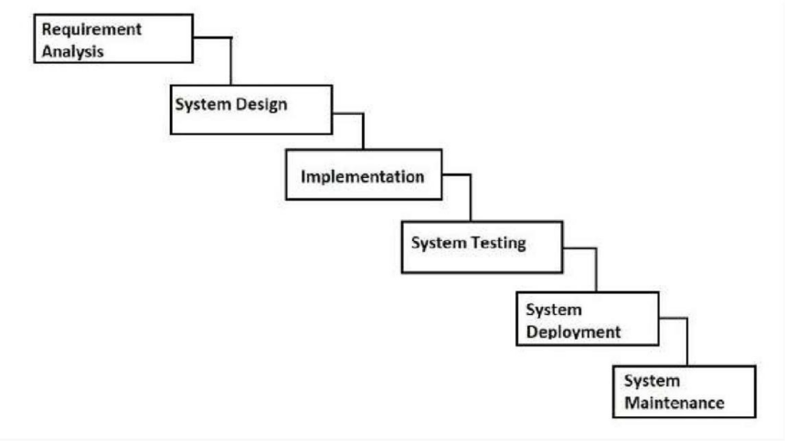

**Feasibility Study**

Before doing the project “Attendance System using Face Recognition System” study and analysing all the existing or required functionalities of the system, the next task is to do the feasibility study for the project. All projects are feasible- given unlimited resources and infinite time. Feasibility study includes consideration of all the possible ways to provide a solution to the given problem. The proposed solution should satisfy all the user requirements and should be flexible enough so that future changes can be easily done based on the future upcoming requirements.

***A. Economic Feasibility***

This is a very important aspect to be considered while developing a project. We decided the technology based on the minimum possible cost factor.

● All hardware and software cost must be borne by the organization.

● Overall, we have estimated that the benefits the organization is going to receive from the proposed system will surely overcome the initial costs and the later running cost for the system.

***B. Technical Feasibility***

This included the study of function, performance and constraints that may affect the ability to achieve an acceptable system. For this we studied complete functionality to be provided in the system, as described in the system. For this feasibility study, we studied complete functionality to be provided in the system, as described in the System Requirement Specification (SRS) and checked if everything was possible using different types for frontend and backend platforms.

***C. Operational Feasibility***

No doubt the proposed system is fully GUI based that is very user friendly and all inputs to be taken are all self-explanatory even to a layman. Besides, proper training has been conducted to let people know the essence of the system so that they feel comfortable with the new system. As far our study is concerned the clients are comfortable and happy as a system has cut down their loads and doing.

***D. Management Feasibility***

This analysis is done for the acceptance of the management or the approving body of the project that is going to be developed.

***E. Social Feasibility***

This feasibility is also for the acceptance but here the acceptance belongs to the people not the management. This determination examines the probability of the project accepted by the group directly or not.

**Software Requirement Specification**

Software Requirement Specification (SRS) is the starting point of the software developing activity. As system grew more complex it became evident that the goal of the entire system cannot be easily comprehended. Hence the need for the requirement phase arose. The software project is initiated by the client needs. The SRS is the means of translating the ideas of the minds of clients (the input) into a formal document (the output of the requirement phase).

The SRS phase consists of two basic activities:

I) ***Problem/Requirement Analysis:***

The process is order and more nebulous of the two, deals with understand the problem, the goal and constraints.

ii) ***Requirement Specification:***

Here, the focus is on specifying what has been found giving analysis such as representation, specification languages and tools, and checking the specifications are addressed during this activity. The Requirement phase terminates with the production of the validate SRS document. Producing the SRS document is the basic goal of this phase.

**Detailed Project Design**

**DFD**

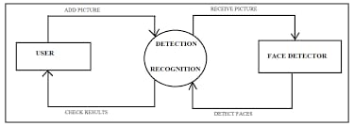

**User Interface & Design**

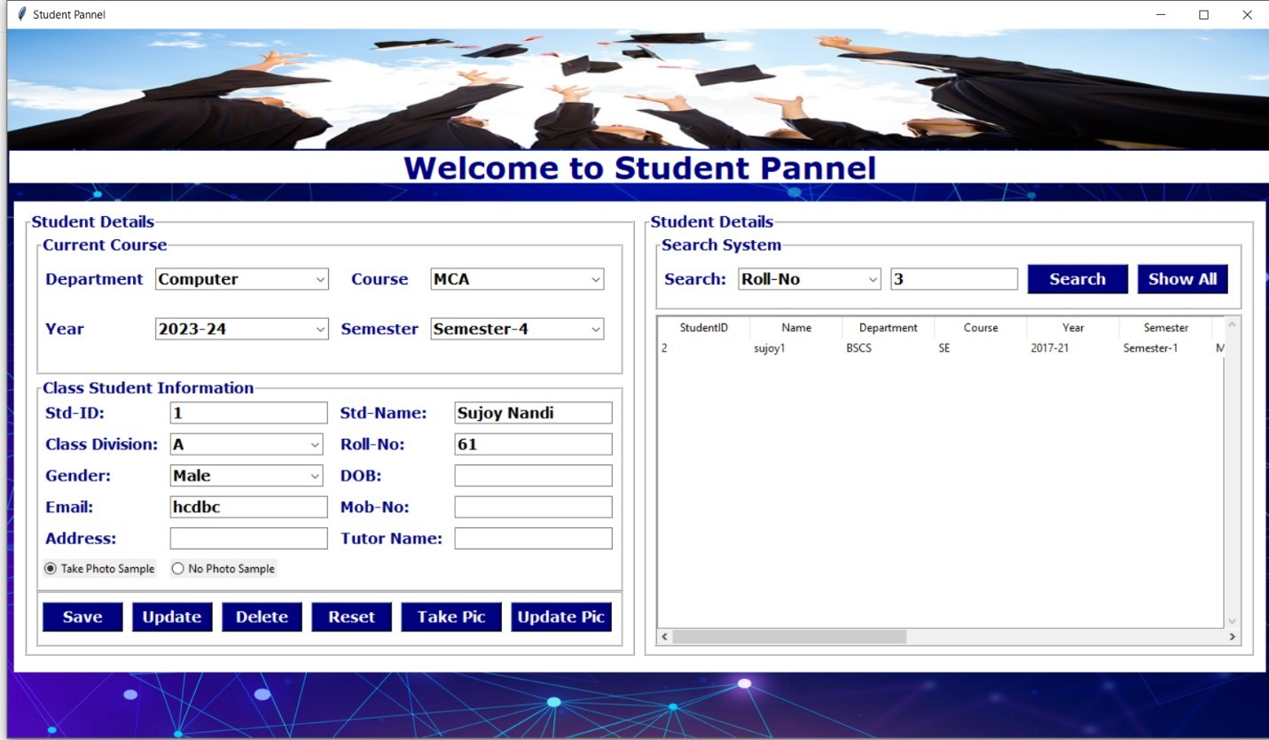

**The Student Panel**

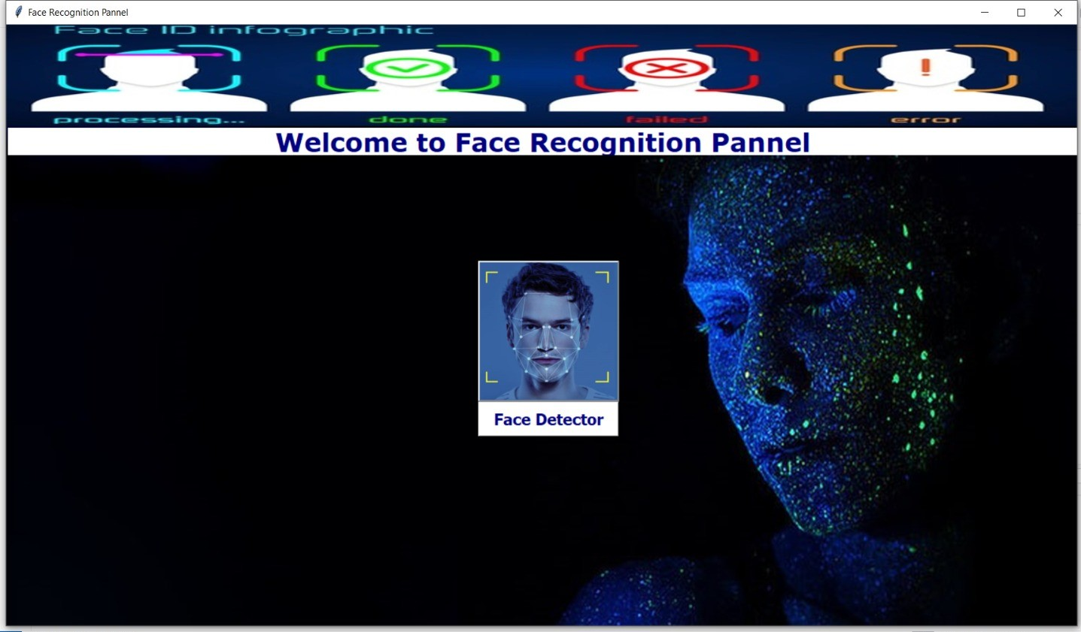

**The Face Detection Panel**

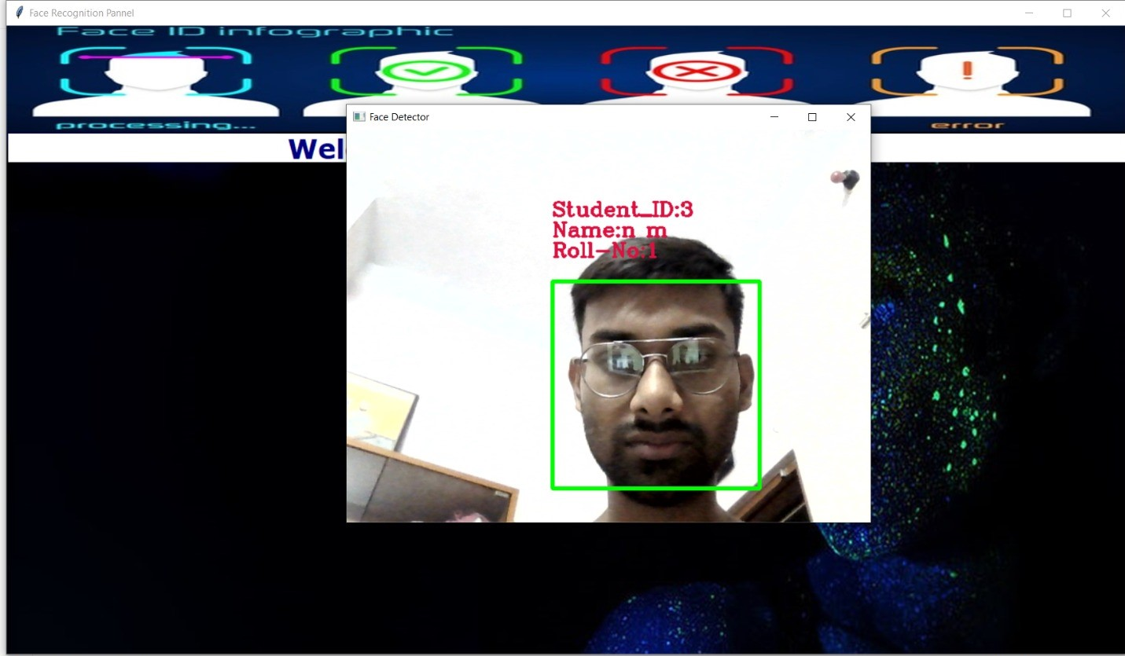

**The Face Captured and Details Fetched from Database**

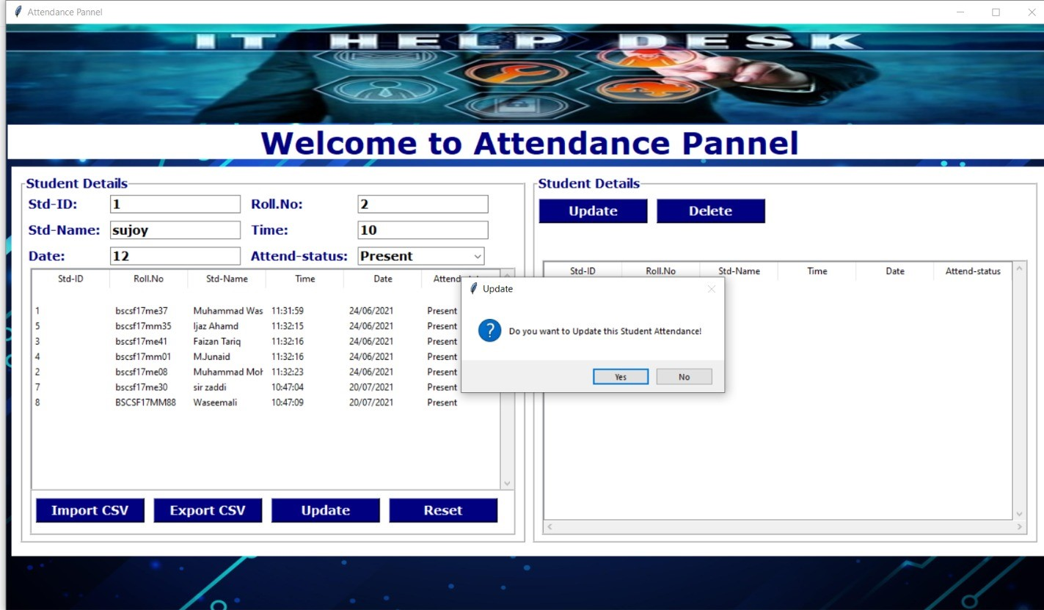

**The Attendance Panel**

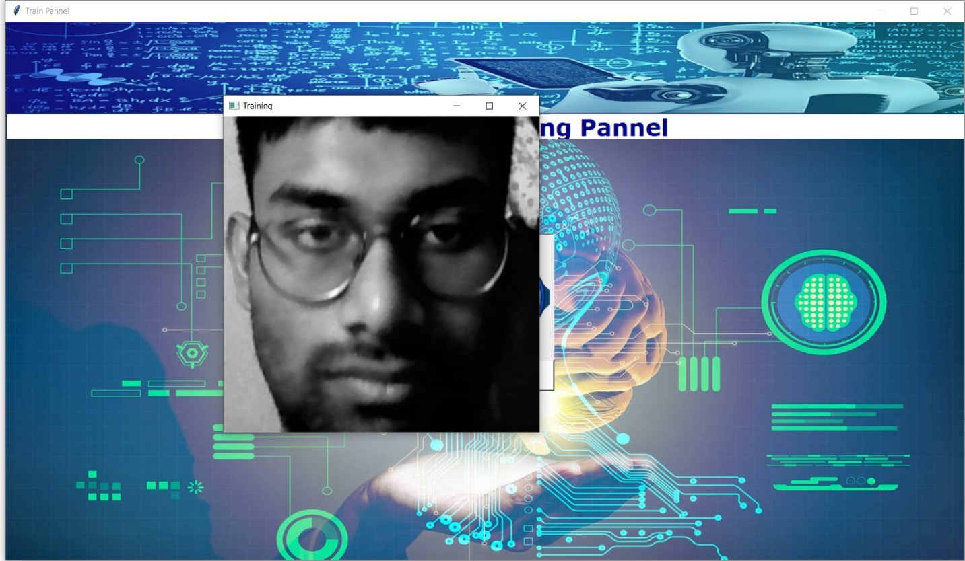

**The Training of Dataset Panel**

**Coding**

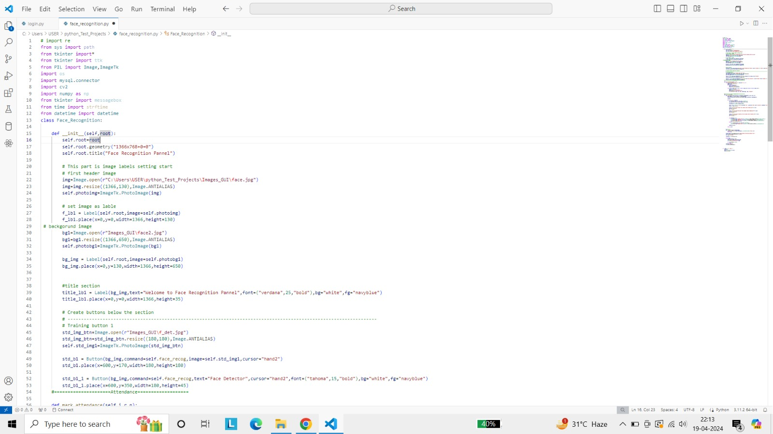

**The Login & Registration Page**

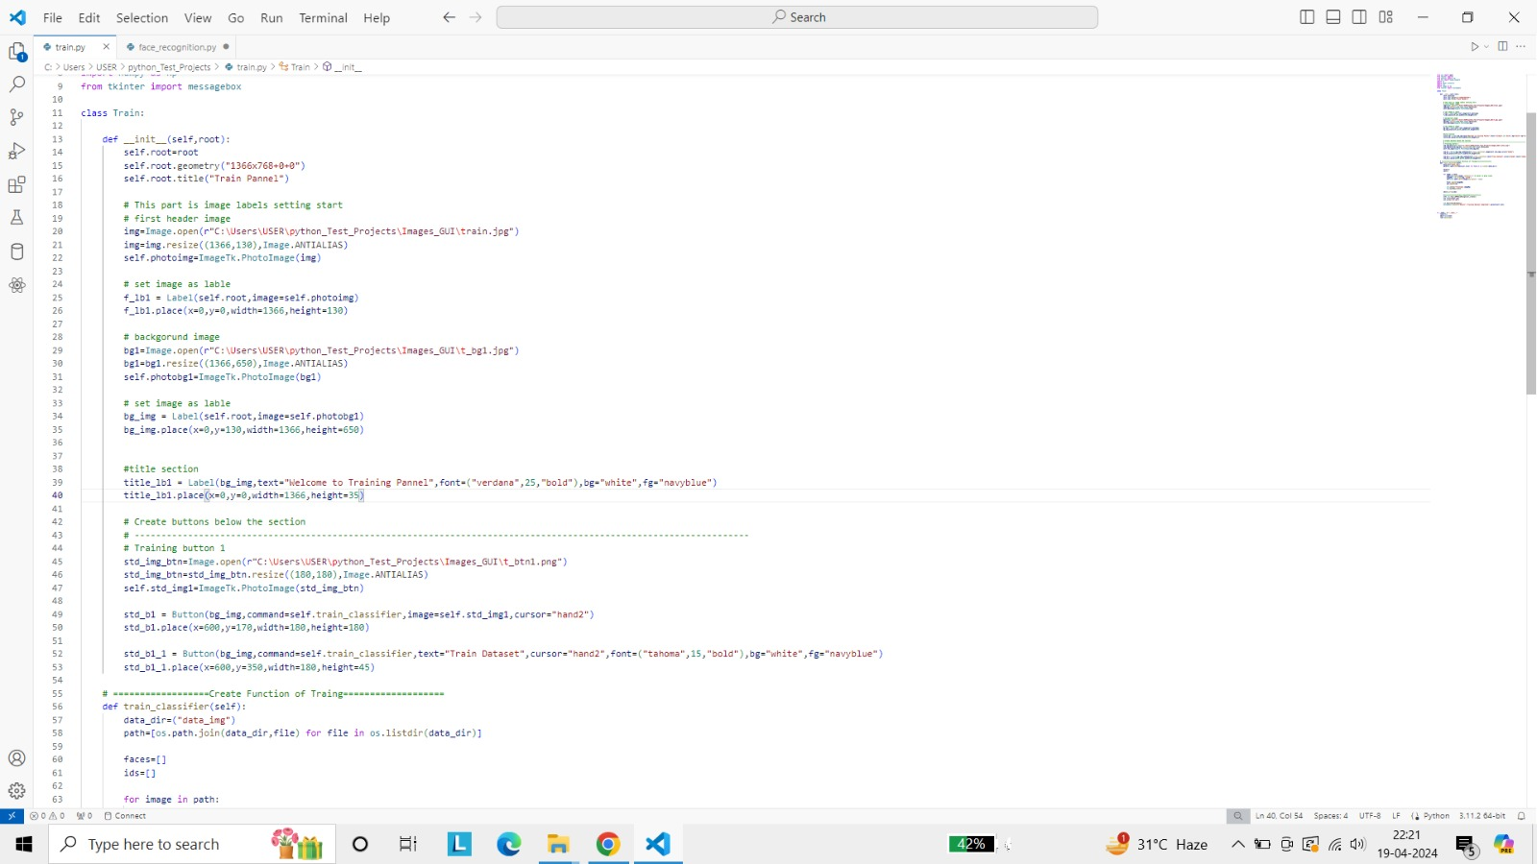

**The Training of Dataset**

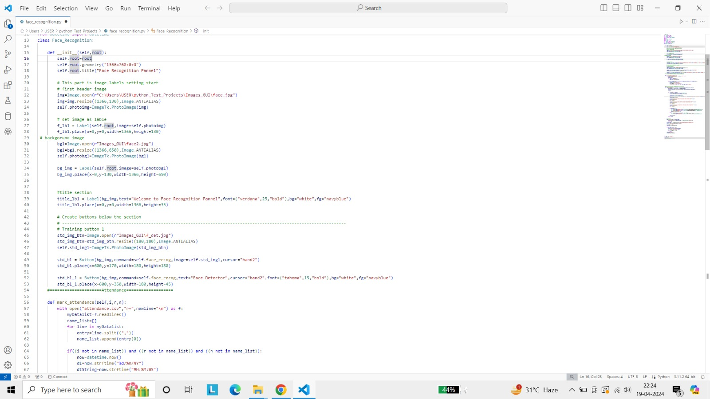

**The Face Recognition**

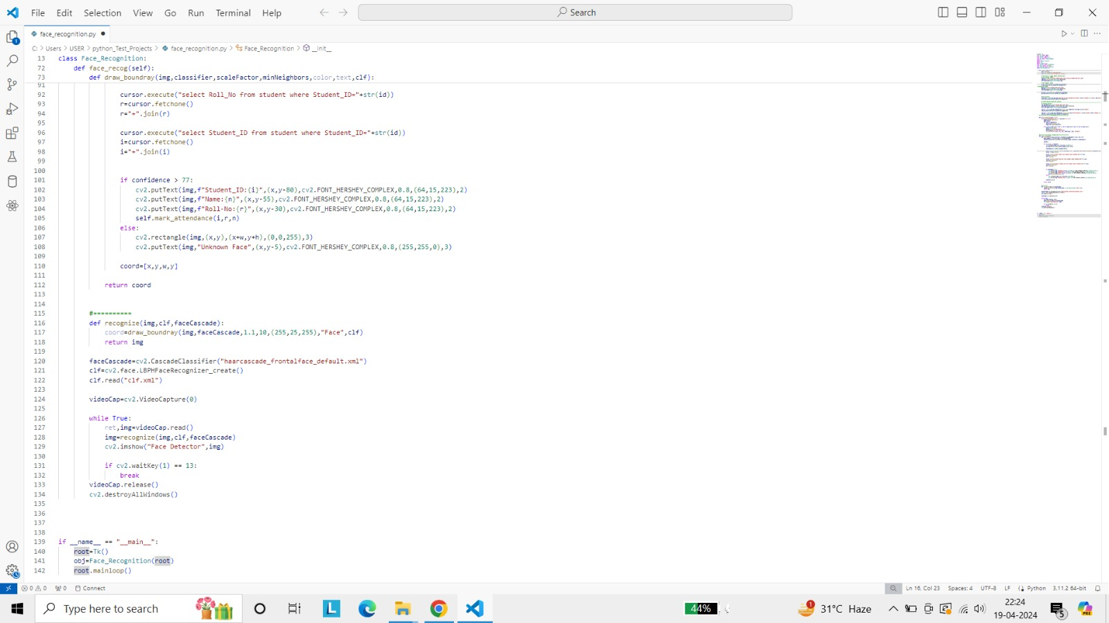

**The Attendance System**

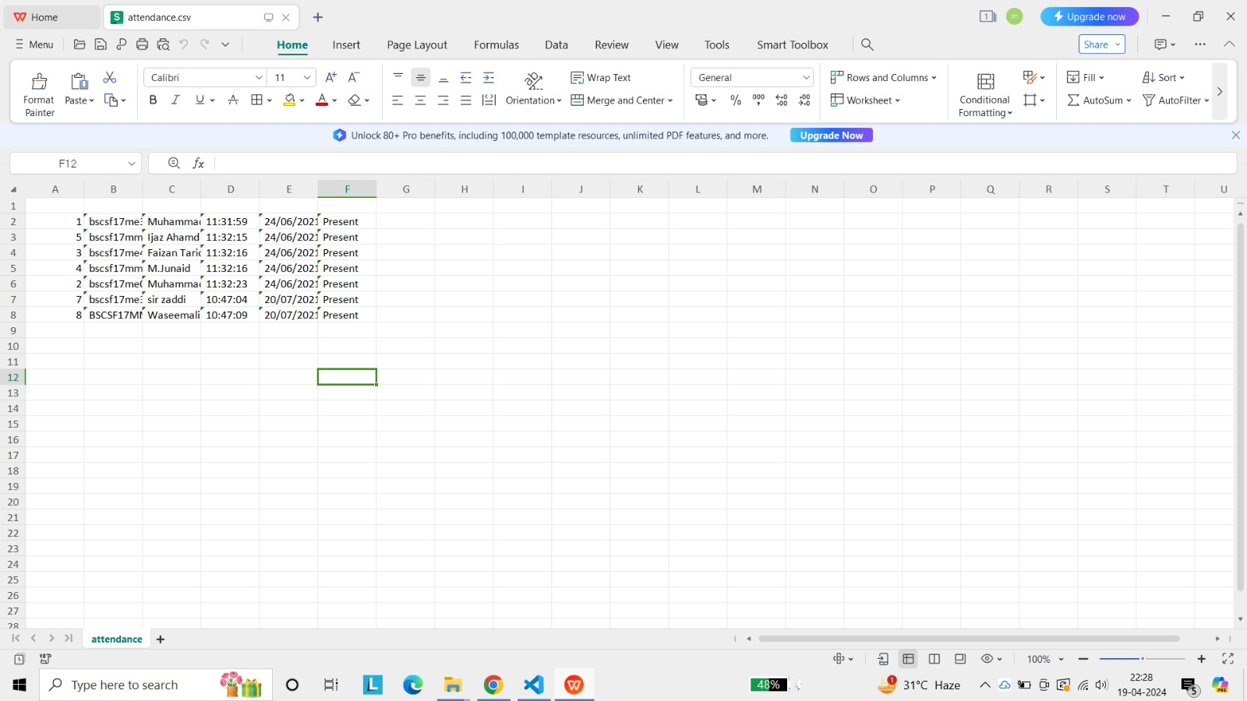

**The Attendance Sheet**

**Testing**

***Characteristics of Testing***

Testing begins at the module level and works outward towards the integration of the entire computer-based system. Different testing techniques are appropriate at different level of time. Testing & debugging are different activities, but debugging must be accommodated in any testing strategy. There is different model of testing. Based on testing methods, there are two types of testing.

***1.Black-box testing***

***2.White-box testing***

**1.Black-Box Testing: -** Black-box tests are used to demonstrate that software function is operational, that input is properly accepted, and output is correctly produced, and that integrity of external information is maintained.

**2.White-Box Testing: -** White-box tests are used to examine the procedural details. It checks the logical paths by test case. It can also check the conditions, loops used in the software coding. It checks that loops are working correctly on defined boundary value.

**Cost Estimation Analysis**

To use facial recognition software, no extra technology is necessary, and hence no maintenance costs are incurred. As compared to other solutions, it is both cost-effective and efficient and human intervention is limited. Hence, there is no requirement for additional employees which reduces costs while enhancing operational efficiency.

**Maintenance**

**Bibliography**

1. www.wikipedia.org
2. www.google.com
3. www.youtube.com